

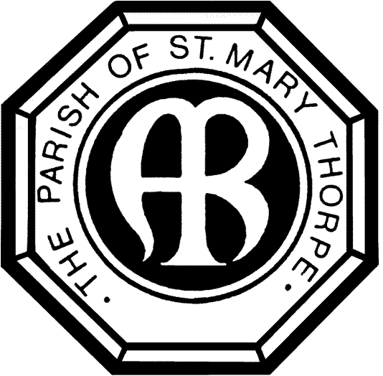

**St Mary’s Church, Thorpe**

Church Approach, Egham, Surrey, TW20 8TQ

Charity No: 1176929. www.stmaryschurchthorpe.co.uk

**Wedding Fees Payment Chart & Documentation 2024**

**Names of Couple:**

|  |  |  |  |
| --- | --- | --- | --- |
| Basic Wedding Fee  (includes all obligatory year-round costs) | Standard Charge  *(set by the Church of England)* | £ 528 | *This includes the Vicar and one hour  Rutherwyke Room Fee.* |
| Publication of Banns Fee | £ 36 |  |
| Verger | £ 50 |  |
| Organist | £ 100 | ***Having an Organist and 3 Hymns is compulsory for every wedding in Church.*** |
|  |  |  |
| **TOTAL BASIC FEE** | **£ 714** | *Wedding blessing equivalent: £678* |
|  | Charge for payment of fees made by Card Machine | £ 5 * |  |
| Heating | Sep-Apr = **£120** | £ -- | *At other times of the year available on request (same charge)* |
| Optional Services Fees | Use of sound systems/ screens/technical support – charge for service **£40** | £ -- |  |
| Tower Bells **£40** | £-- |  |
| Wedding Candle **£40** | £-- |  |
| Recording Fee **£150** | £-- | *This* covers *the licence and additional organist fee – you need to provide the videographer.* |
| Choir **£60** | £-- |  |
| *Flowers through Flower Guild  as per agreement (contribution to Church towards Sunday flowers)*  *(if using outside florist -* ***£45)*** | £-- |  |
| ***Total fee payable for your wedding:***  ***Less deposit\*\****  ***Balance Payable*** | | **£--**  **£200.00**  **£--** |  |

* A charge applies for the payment of fees by debit/credit card or you can pay fees via bank transfer to Thorpe Parochial Church Council, Account Number 10884901, Sort Code 20-81-11 with Barclay’s Bank. All fees must be paid in full before the reading of your banns at St Mary’s.

**Non-refundable deposit payable on booking a wedding in 2024/25 is **£200**.

**BANNS OF MARRIAGE**

Please note that if you are resident within another parish you are required to arrange for your banns to be called in that parish also. The same is true for *each* parish in which you reside. They will charge you a fee and provide you with a certificate. It is *your responsibility to arrange this* and bring the certificate with you (in advance of the rehearsal).

***Signature of bride & groom to confirm Away Banns advice received***____________________________________

You should make every effort to attend at least one occasion wherever your banns are read. At St Mary’s, this usually takes place at the 10am Parish Eucharist on the first three consecutive Sundays of the month preceding the date of your wedding:

Proof of Identification seen – Date: ___________________

*Copies made for PCC records:*

**UK Passport Yes/No**

**Driving Licence Card Yes/No**

**Proof of Address Yes/No**

X

|  |  |
| --- | --- |
| 1st Sunday |  |
| 2nd Sunday |  |
| 3rd Sunday |  |

|  |  |  |  |  |  |
| --- | --- | --- | --- | --- | --- |
| **FOR**  **PARISH OFFICE USE ONLY** | DATE OF CEREMONY | TIME OF  CEREMONY | OFFICIANT | DATE DEPOSIT PAID | REHEARSAL DATE & TIME |
|  |  |  |  |  |