**YOUR WEDDING**

**Christian Basis and Guidance**

**St Mary’s Church, Thorpe**

**Church Approach, Egham, Surrey, TW20 8TQ**

**Charity # 1176929**

[www.stmaryschurchthorpe.co.uk](http://www.stmaryschurchthorpe.co.uk)

**Administrator: Mary Morris**[stmaryschurch](mailto:petra@phcrafts.plus.com)thorpe@outlook.com

**01932 567603**

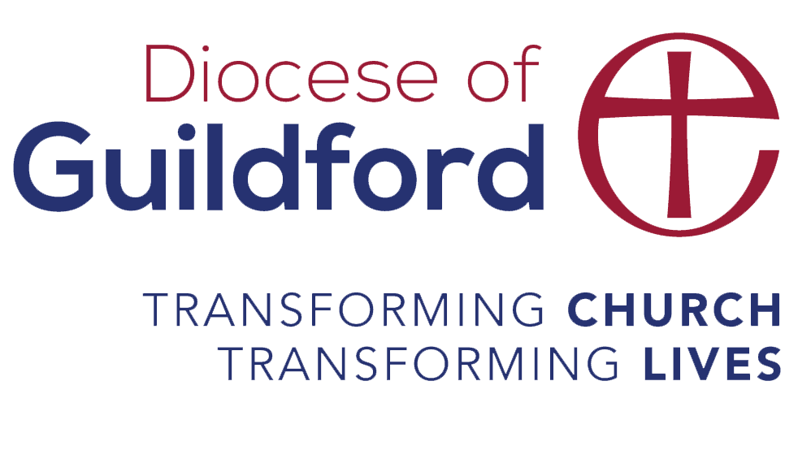

Contents

MARRIAGE FROM A CHRISTIAN PERSPECTIVE 2

The Sacrament of Marriage 2

Thinking about Marriage 3

Being prepared for marriage… The three C’s of Marriage! 4

Thinking about things that are important to each person in a relationship 4

Happy Ever After? 5

Marriage as a sign of God’s love for us 6

The Wedding Sermon 6

# MARRIAGE FROM A CHRISTIAN PERSPECTIVE

## The Sacrament of Marriage

It is all too easy for us to be caught up in the excitement of the time and perhaps miss the deeper meaning of the occasion. Yet most of us believe there is something sacred and special about marriage. We may not always have been able to express that in words – some simply feel that they wouldn’t be married properly if they weren’t married in church and for others there is a real sense in which they want to make their marriage vows in the church: blessed by the presence of God. For most a church wedding is about making vows to the person they love before family and friends and it is a ‘rite of passage’ and the only opportunity to mark a change in their lives. In marriage we cease to be single and become joined to the one we love.

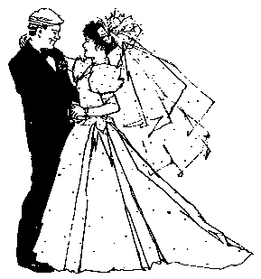

Christians believe that marriage is God given and we consider it to

be one of the Sacraments* of the Church. Put simply, a Sacrament is

“an outward sign of something that God is doing on the inside of us.”

Sacraments touch our everyday lives and remind us that life is to be lived

out fully, transformed by the presence of Jesus Christ. Sacraments are

God given signs to us of his love and care. For the vast majority of people

marriage is the way in which they will live out their adult lives and therefore

it is the place in which they may develop their relationship with God.

In almost every human culture, Christian and non-Christian, men and

women get married and it is hard to argue therefore that it is not a God

given gift.

*\*The Seven Sacraments of the Church are considered to be marriage, baptism, confirmation, Holy Communion, ordination, confession and anointing the sick.*

## Thinking about Marriage

Which of these road signs best describes your understanding or view of marriage? Mark your first, second and third choice in order of priority, number one being the highest priority.

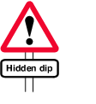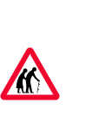











6.

7.

8.



### Being prepared for marriage… The three C’s of Marriage!

• Communication

• Constructive Conflict

• Commitment

A lasting marriage usually consists of the 3 C’s… These are three aspects that help two people in love strengthen the bond between them into a lifelong relationship.

*Communication*

As in all aspects of life today, communication is essential. First of all, we need to listen. Take time to listen to each other regularly. Make sure that each day you have spent time in listening to your partner. Understand that listening to the other person is more important than trying to solve their problems for them.

*Constructive Conflict*

Nobody likes conflict, but it is an inevitable aspect of any healthy relationship. How we handle our conflict is an essential tool for marriage. It is important to express our feelings effectively. This means listening to our partner and allowing them time to offer their feelings and thoughts without interrupting them and then being allowed time for us to do the same. In relationships it is important to learn to forgive and say sorry and really mean it.

*Commitment*

Without commitment the best of relationships will fall apart. Commitment is that which binds two people together in honesty and mutual affection; after all, real love wants what is best for the other person. Love and commitment are more about our will than our feelings. If we are strong in our commitment, our feelings follow.

Remember that every relationship is unique! We are all different, and we are always growing and changing as life challenges us. Therefore, we need to re-evaluate our relationships from time to time. This is healthy! Never cease to ask each other questions and always be prepared to work at finding the answers together.

### Thinking about things that are important to each person in a relationship

As individuals, take a look at the list below, and place your initials in the appropriate column depending on whether the item is important to you or not. (Don’t pay attention to what your partner feels – just put down what **YOU** feel. *You will find the task more fun!*

|  |  |  |  |
| --- | --- | --- | --- |
|  | Very | Fairly | Not at all |
| Being tidy |  |  |  |
| Organisation |  |  |  |
| Healthy eating |  |  |  |
| Punctuality |  |  |  |
| Reading |  |  |  |
| Shopping |  |  |  |
| Sport |  |  |  |
| Going out with friends |  |  |  |
| Family time |  |  |  |
| Keeping promises |  |  |  |
|  | Very | Fairly | Not at all |
| My own friends |  |  |  |
| Spirituality |  |  |  |
| Inviting people home |  |  |  |
| Showing affection |  |  |  |
| Saying ‘I love you’ |  |  |  |
| Public displays of affection |  |  |  |
| Having time to myself |  |  |  |
| Talking together regularly |  |  |  |
| Keeping the peace |  |  |  |
| Honesty |  |  |  |
| Keeping to a strict budget |  |  |  |
| Promotion at work |  |  |  |
| Volunteering |  |  |  |
| Surprises! |  |  |  |
| Having children / adoption |  |  |  |
| Going to church |  |  |  |
| Savings & investment |  |  |  |
| Getting my own way |  |  |  |
| Making careful decisions |  |  |  |
| Living in a particular area |  |  |  |
| Walks in the countryside |  |  |  |

How do the two results compare? Do you really know what your partner is thinking? Take time to talk about some of the things you did know about each other and anything which you didn’t!



### Happy Ever After?

St Mary’s Church hopes so and we pray that you will have a very happy life together. See below a list of values that people often think are vital for a good marriage. What do you think?

Put them in order of importance to YOU by rating them 1 – 18. Start with what you think is most important – making it number 1 – and so on. (You may like to fold the page along the black line, so that you and your partner can complete the task separately, and later compare your answers!)

**Her List**  **His List**

1. Give & Take ( ) 1. Give & Take ( )

2. Our own home ( ) 2. Our own home ( )

3. Listening to/understanding each other ( ) 3. Listening to/understanding each other ( )

4. Companionship ( ) 4. Companionship ( )

5. Trust ( ) 5. Trust ( )

6. Agreement about religion ( ) 6. Agreement about religion ( )

7. Going to church together ( ) 7. Going to church together ( )

8. Honesty ( ) 8. Honesty ( )

9. Love ( ) 9. Love ( )

10. Getting on with the In-laws ( ) 10. Getting on with the In-laws ( )

11. Sense of humour ( ) 11. Sense of humour ( )

12. Sexual compatibility ( ) 12. Sexual compatibility ( )

13. Awareness of each other’s needs ( ) 13. Awareness of each other’s needs ( )

14. Having children ( ) 14. Having children ( )

15. Time to oneself (Independence) ( ) 15. Time to oneself (Independence) ( )

16. Agreeing on money matters ( ) 16. Agreeing on money matters ( )

17. My career ( ) 17. My career ( )

18. Any other _________________ ( ) 18. Any other ________________ ( )

Did any of your partner’s answers surprise you? Talk them through together.

## Marriage as a sign of God’s love for us

At the heart of the Christian faith is the belief that God has created the world and us, human beings, because he wants to form a relationship with us. As Christians we would say that this is the purpose of creation, our relationship with God and his love for us; we call this the covenant relationship. God, who is love, wishes to open himself to us and to share his life with us.

In the person of Jesus Christ, God is responding to the fact that human beings turned away from his love. Yet God has always wanted us to live in relationship with him. Through Jesus’ birth in Bethlehem (which we celebrate at Christmas) and his death upon the cross and resurrection (celebrated at Easter), that relationship with God is restored and we can become as God intended us to be – his children. This is indeed a covenant relationship in which we are blessed as individuals and as a community of faith – and in marriage.

Jesus is the sign and the presence of God’s love and we are invited to share this love, by living our lives in relation to God. One of the ways in which we do this is by participating in the signs of God’s love, the Sacraments of which we have already said Marriage is a part. That is why we take marriage seriously in the church, because in marriage we experience something of God’s love and we find our fulfilment, for we enter with God into the nature of creation.

What we believe is that God’s love is given in marriage and is expressed in the love of a husband for his wife and a wife for her husband. A love which is self-giving and is, we pray, life-long. This Sacrament of love is confirmed as vows are exchanged and continues as those vows are lived out in the unfolding relationship that follows.

There are four signs of this living out of Christ’s love:

• Obedience *- a word we don’t much like today, but it makes the point!*

• Faithfulness

• Self giving

• Love *- a word which is often over used but very important!*

*Obedience*: as seen in Jesus is not about one being superior to the other; it is rather about our essential belonging and commitment to another. We may prefer a term like fidelity. Obedience requires us to submit oneself to another out of a total unity of purpose. It is commitment in relationship. Husband and wife are called to behave in a ‘Christ-like’ way, each acting as Christ to the other, or in other words always showing love for one another. Obedience is not out of fear or inequality but because we become one in marriage, which requires balance, each bringing their own valued gifts to the relationship. It is oneness and togetherness that demands commitment to each other. In marriage you will belong to one another with each giving your total self to the other. You will live for what is good in each other, always responding to the needs of each other.

*Faithfulness:* Jesus made his faithfulness known to us by giving his whole self on the cross and has promised to be with us always. In Church worship we celebrate his gift of love demonstrated upon the cross and praise him for what he has done for us. Our faithfulness requires commitment and is far more difficult to achieve, in that we can become used to each other and sometimes fall into the trap of comparing ourselves to other married couples; in this context our commitment can slip as we don’t give ourselves fully to each other. We rely on Christ’s presence to reinforce our faithfulness so that we can fully give ourselves to the other. Obedience and faithfulness need a channel of communication and openness. A life-long relationship means accepting the other, warts and all.

*Self-Giving*: Making ourselves completely available to the one we love through total self-giving: bodily, emotionally, socially, intellectually and spiritually. Jesus did not withhold any part of himself. In marriage a couple will want to give and receive as much of each other as possible – being open and honest about even the deepest parts of who we are. This exchange leads to an availability of body, feelings, mind and spirit. This is something we need to keep working at, something which is in constant need of new energy to realize fully the fullness of your relationship.

*Love*: St. John tells us that God is Love. In Jesus we see this love lived out in obedience, faithfulness and self-giving. Through this love, God working through his son Jesus is able to sustain and heal and help humanity grow. Love is the means through which spouses sustain, heal and help each other to grow; loving sensitively is something which we must keep working at. At the heart of God is a relationship of Love between the Father, the Son and the Holy Spirit. Marriage reflects this life giving, loving relationship which unfolds over a lifetime.

In marriage you will begin your unique vocation to live as husband and wife - a loving encounter which will sustain you through the decades and may bring you the joy of children. It is a life of love which precedes children and continues after their departure into the world having been nurtured by you, with the support of the wider church family.

Marriage is a sacrament of the church; it starts with the taking of vows in which spouses surrender themselves to each other and continues in the lifelong committed relationship of love. This relationship is marked by obedience, faithfulness, self-giving and love, the characteristics which are found in the relationship of Christ with us.

## 

## The Wedding Sermon

*… a bit of fun …*

*As he sped each couple coyly on its blushing bridal way*

*And with horticultural metaphor he warned each newly wed*

*Of the pleasures and the pitfalls which were hovering overhead.*

*Marriage is like a garden, he said. You’re going to need*

*To succour every seedling and to banish every weed.*

*You’ll have to work, to give your all, for if you offer less*

*A garden or a marriage becomes a wilderness.*

*Marriage is like a garden. Spread the fertiliser thickly*

*Or the plant that you neglect*

*will grow up weak and wan and sickly.*

*Never think that you have finished,*

*For despite the aches and pain,*

*Every morning you will find you have to do it all again.*

*Marriage is like a garden. Put a fence around its limit*

*To reduce the possibility of interference in it.*

*But not a prison wall – keep the fencing open so*

*There’s light to keep your flowers strong*

*And room so they can grow.*

*Marriage is like a garden. Put a fence around its limit*

*To reduce the possibility of interference in it.*

*But not a prison wall – keep the fencing open so*

*There’s light to keep your flowers strong*

*And room so they can grow.*

*Marriage is like a garden – if it’s any good at all*

*The blossom in the spring will lead to the harvest in the Fall,*

*And the mowing and the trimming and the tilling of the soil*

*Will create a world of beauty from the effort and the toil.*

*‘Marriage is like a garden’ - and the Vicar’s wife would smile*

*As she saw the wedding party Bridal marching down the aisle,*

*For while he praised the gardeners work, The Vicar quite forgot*

*That in the Vicarage garden - His wife did all the lot.*

We wish you every prayer and blessing as you continue in your marriage preparations. Also be assured of the prayers of the people of St Mary’s Church, Thorpe. We are here to support you and pray for you and make your special day the most wonderful experience possible.

 